Q1)Each Sunday, a newspaper agency sells X copies of a certain newspaper for Rs.A per copy. The cost to the agency of each newspaper is Rs.B . The agency pays a fixed cost for storage, delivery and so on of Rs.100 per Sunday. [The newspaper agency](http://www.rajalakshmicolleges.org/moodle/mod/quiz/view.php?id=54" \o "The Newspaper Agency) wants to calculate the profit obtained on Sundays. Can you please help them out by writing a C program to compute the profit given X, A and B.

**Input Format:**

Input consists of 3 integers: X, A and B. X is the number of copies sold, A is the cost per copy and B is the cost the agency spends per copy.

**Output Format:**

Refer Sample Input and Output for exact formatting specifications.

**Sample Input and Output:**

Input

1000

2

1

Output

900

**For example:**

| **Input** | **Result** |
| --- | --- |
| 1000  2  1 | 900 |

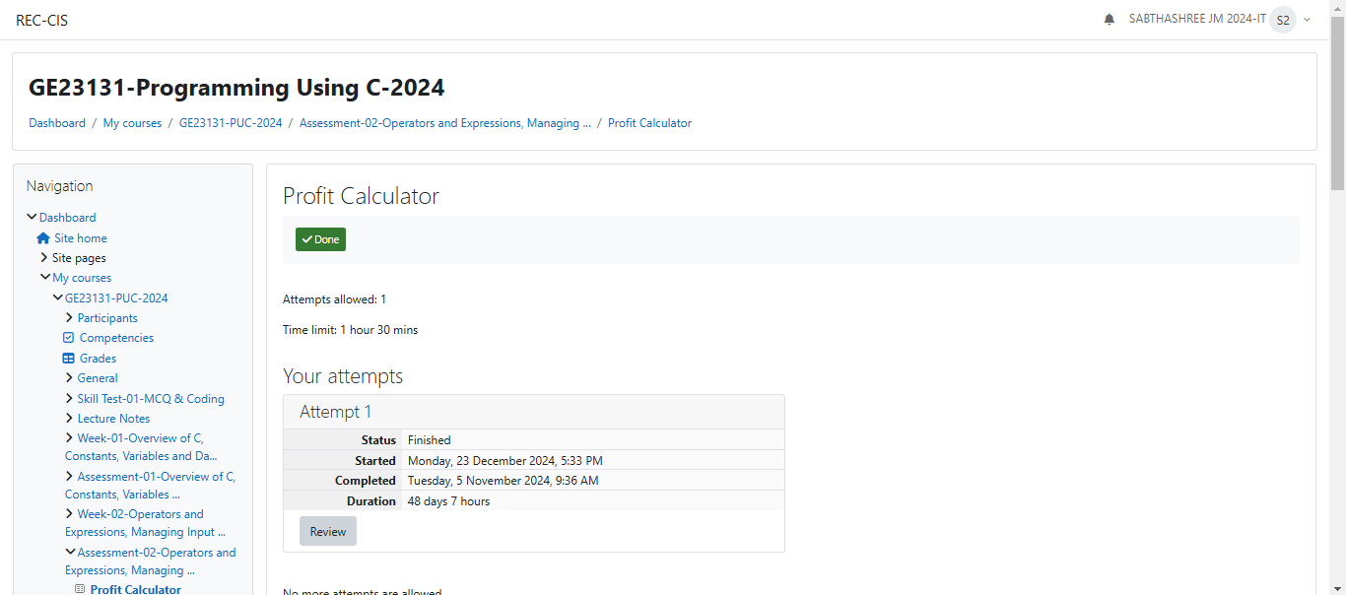

`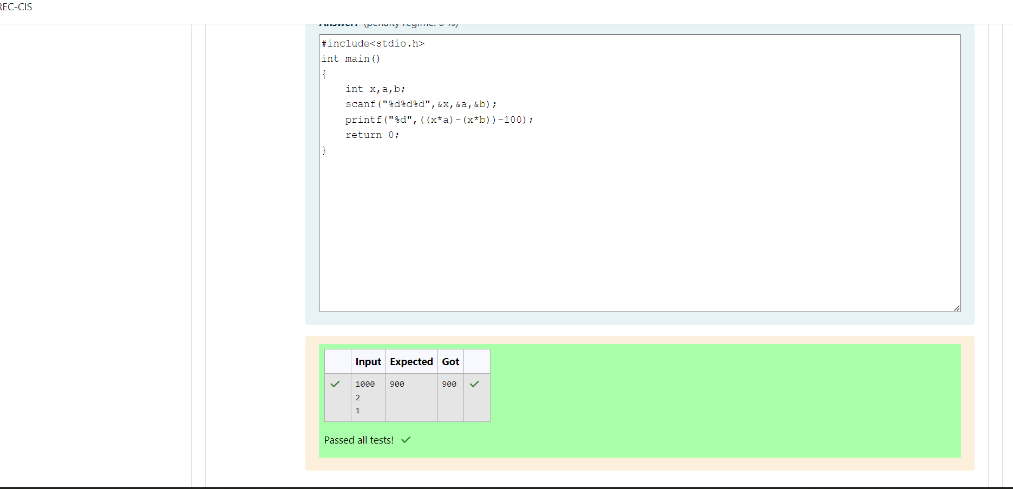

Q2)Baba is very kind to beggars and every day Baba donates half of the amount he has when ever a beggar requests him. The money M left in Baba's hand is passed as the input and the number of beggars B who received the alms are passed as the input. The program must print the money Baba had in the beginning of the day.

**Input Format:**  
The first line denotes the value of M.  
The second line denotes the value of B.

**Output Format:**  
The first line denotes the value of money with Baba in the beginning of the day.

**Example Input/Output:**  
Input:  
100  
2

Output:  
400

Explanation:  
Baba donated to two beggars. So when he encountered second beggar he had 100*2 = Rs.200 and when he encountered 1st he had 200*2 = Rs.400.

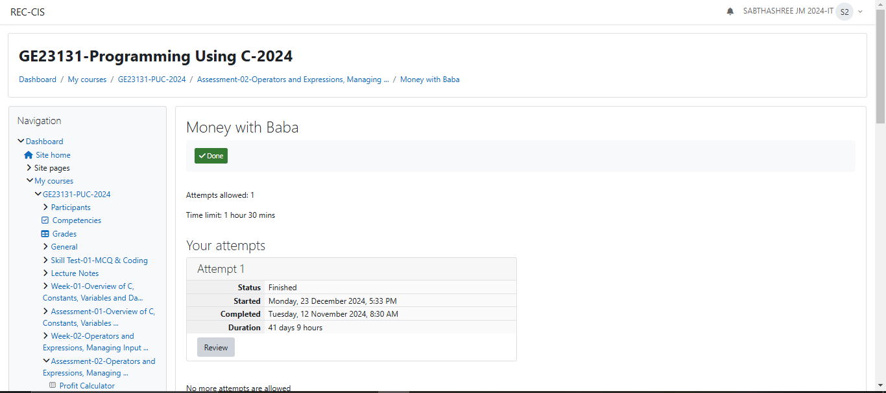

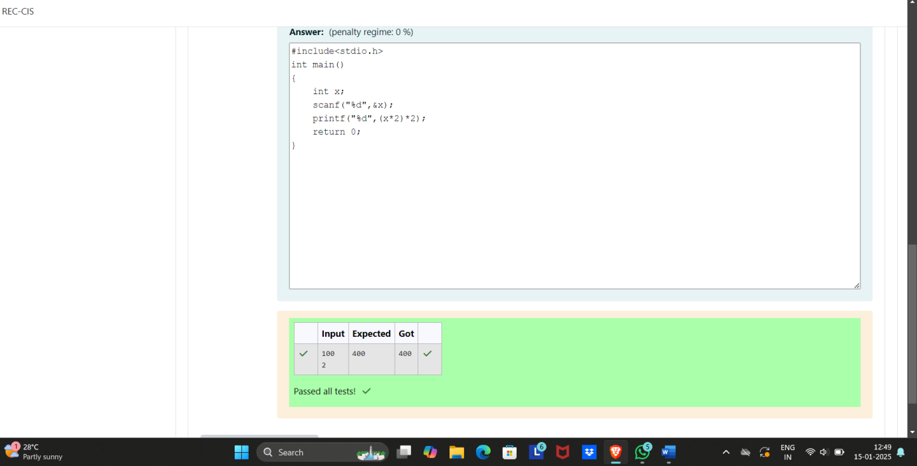

Q3)The CEO of company ABC Inc wanted to encourage the employees coming on time to the office. So he announced that for every consecutive day an employee comes on time in a week (starting from Monday to Saturday), he will be awarded Rs.200 more than the previous day as "Punctuality Incentive". The incentive I for the starting day (ie on Monday) is passed as the input to the program. The number of days N an employee came on time consecutively starting from Monday is also passed as the input. The program must calculate and print the "Punctuality Incentive" P of the employee.

**Input Format:**  
The first line denotes the value of I.  
The second line denotes the value of N.

**Output Format:**  
The first line denotes the value of P.

**Example Input/Output:**  
Input:  
500  
3

Output:  
210

Explanation:  
On Monday the employee receives Rs.500, on Tuesday Rs.700, on Wednesday Rs.900  
So total = Rs.2100

**For example:**

| **Input** | **Result** |
| --- | --- |
| 500  3 | 2100 |
| 100  3 | 900 |

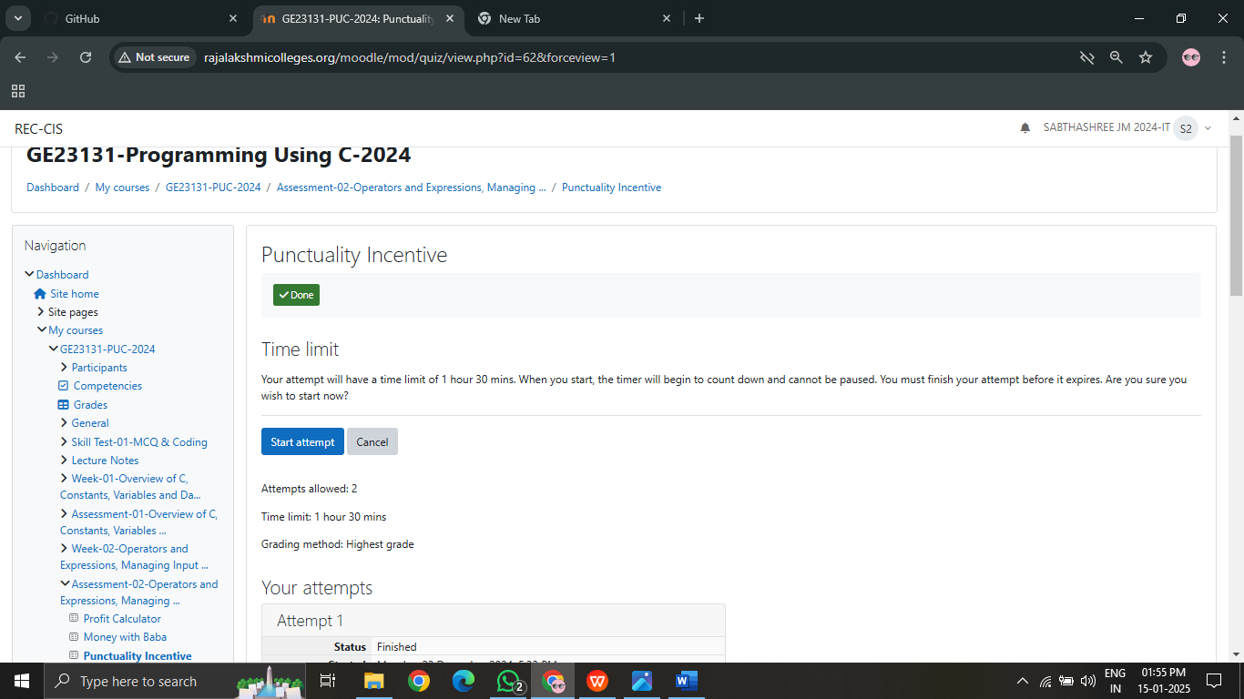

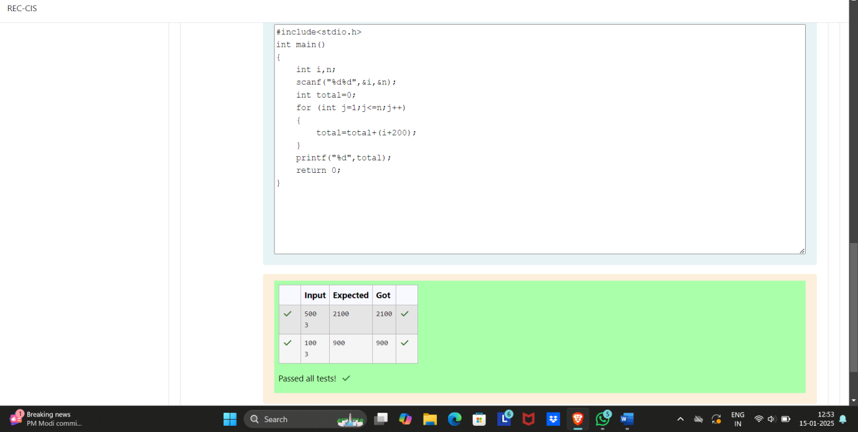

Q4)Bajan Lal distributes C chocolates to school N students every Friday. The C chocolates are distributed among N students equally and the remaining chocolates R are given back to Bajan Lal.

As an example if C=100 and N=40, each student receives 2 chocolates and the balance 100-40*2 = 20 is given back.

If C=205 and N=20, then each student receives 10 chocolates and the balance 205-20*10 = 5 is given back.

Help the school to calculate the chocolates to be given back when C and N are passed as input.

**Input Format:**  
The first line denotes C  
The second line denotes N

**Output Format:**  
The first line denotes R - the number of chocolates to be given back.

**Example Input/Output:**  
Input:  
300  
45

Output:

30

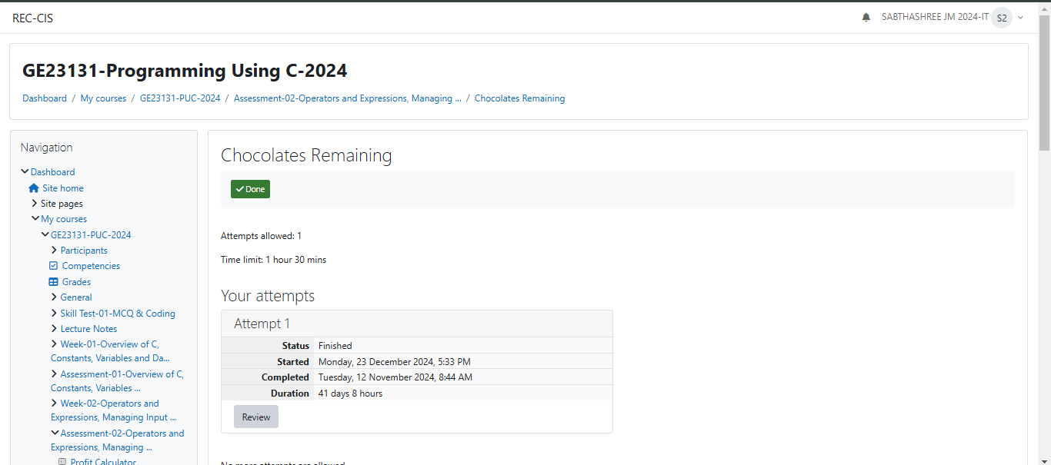

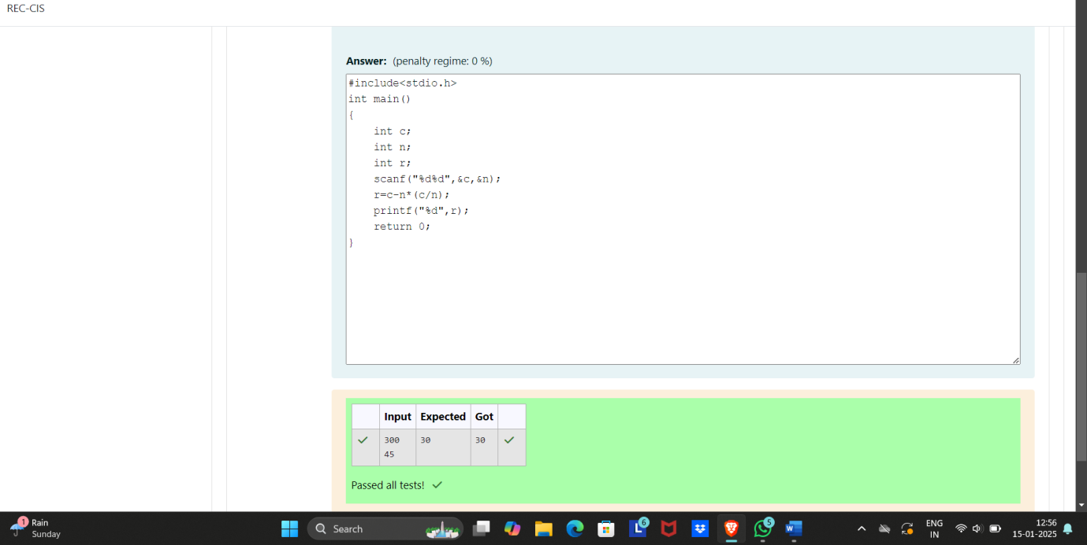

Q5)The general format of if statement is  
if (condition) {

statement-1;

statement-2;

....

statement-n;

}

The if construct is a **selective statement**, the statements within the block are executed only once when the **condition evaluates to true**, otherwise the control goes to the first statement after the if construct.

If only one statement is presented in the if construct then there is no need to specify the braces {, } i.e., if braces are not specified for the if construct, by default the next immediate statement is the only statement considered for the if construct.  
Below code prints the number only when it is **divisible by 3**:  
#include <**stdio.h**>

**int** main()   
{

**int** num;

printf("Enter a number : ");

scanf("%d", &num);

if (**num % 3 == 0**)   
 {

printf("Given number %d is divisible by 3", num);

}  
 return 0;

}

In the above code, num % 3 == 0 is the **condition**, which verifies whether the **number is divisible by 3**. Only if the condition returns 1 (true) then the control enters in to the **if-block** and executes the statement.  
  
Fill in the missing code in the below program to check whether the given number is divisible by **3** or not.

**For example:**

| **Input** | **Result** |
| --- | --- |
| 9 | Given number 9 is divisible by 3 |
| 7 | Given number 7 is not divisible by 3 |

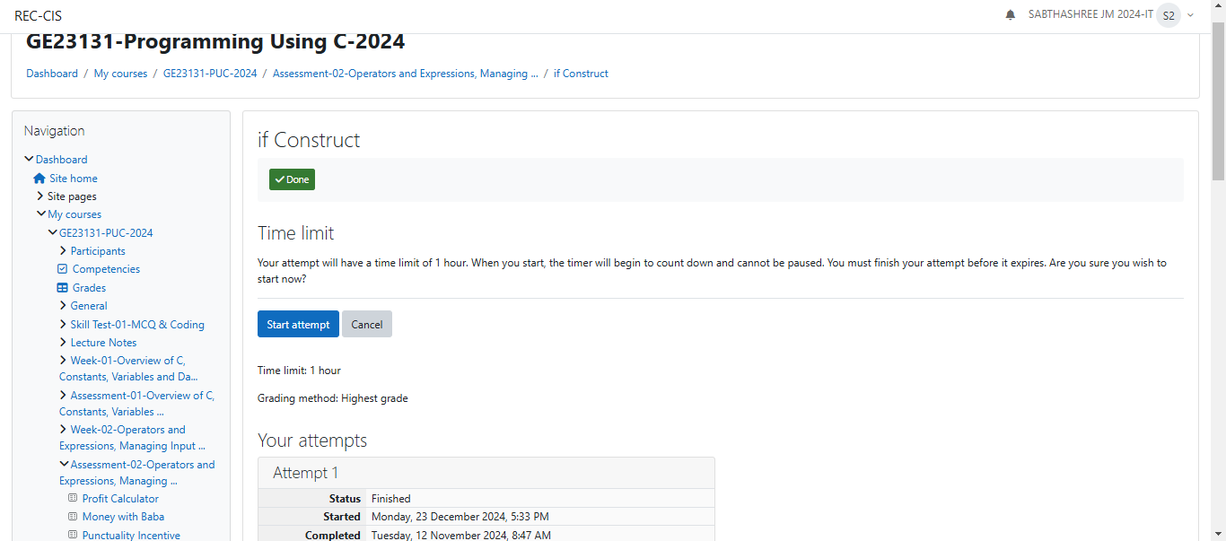

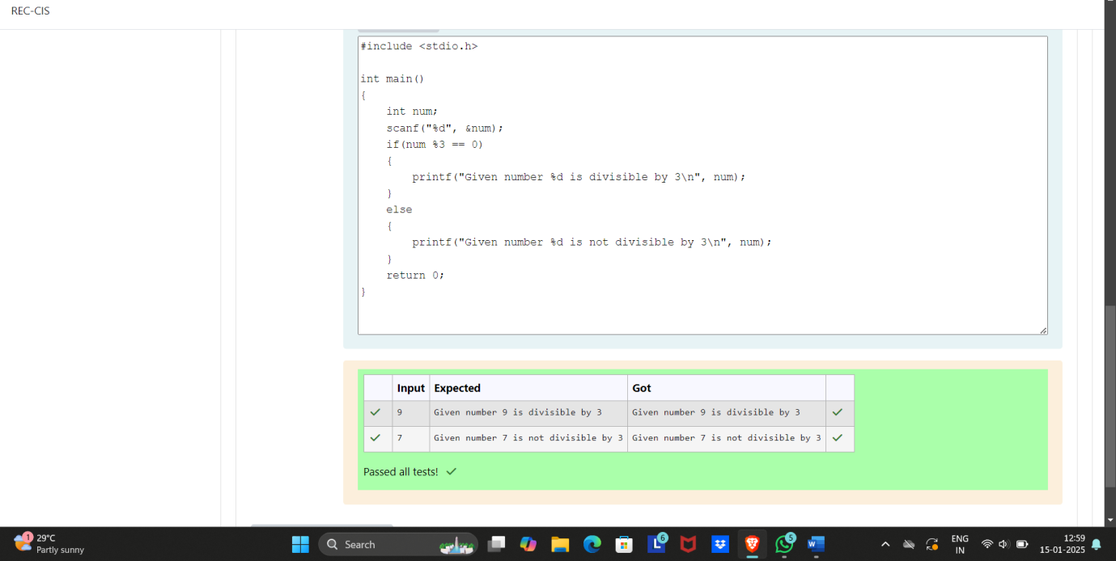

Q5i)The if statement tells a program to execute a certain section of code only if a particular test evaluates to true. if (*expression*) {*statement*}.  
Below is a sample code which uses a if statement:  
**int** distinction_marks = 75;

if (marks > distinction_marks)   
{

printf("User secured distinction.\n");

}

An if statement will execute its block only when condition evaluates to 1 (**true**).  
We can also conditionally execute another block when the condition evaluates to 0 (**false**) using the else construct. The else construct must be attached to an if, hence together they are referred to as if-else construct.  
The if-else statement provides two different paths of execution depending on the result of condition.Below is the general syntax for the if-else statement :  
if (expression)   
{

statement-1;

}   
else   
{

statement-2;

}

Below is an example with code:  
**int** distinction_marks = 75;

if (marks > distinction_marks)   
{

printf("User secured distinction.\n");

}   
else   
{

printf("User did not secure distinction.\n");

}

Fill in the missing code in the below program to check whether the user secured distinction or not.  
**For example:**

| **Input** | **Result** |
| --- | --- |
| 76 | User secured distinction. |
| 21 | User did not secure distinction. |

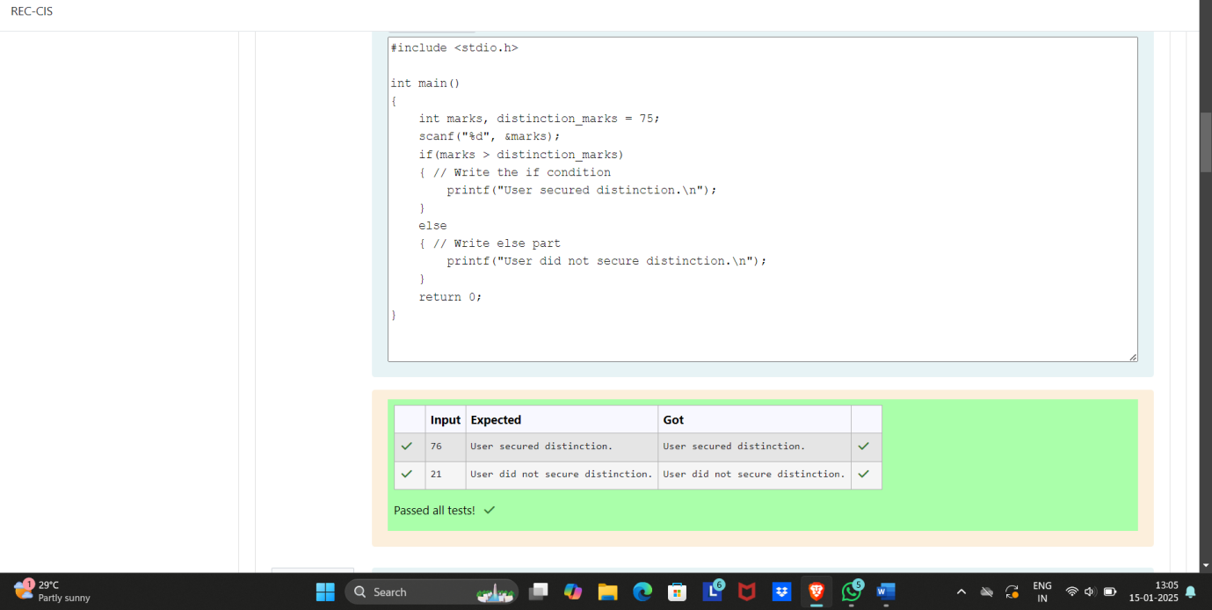

ii)Write code which uses an if-else statement to check whether a given account balance is greater or lesser than the minimum balance.  
Use the if-else statement and print "Balance is low" if the balance is less than **1000**, otherwise print "Sufficient balance".  
For example, if the user gives the **input** as 1500:

1500

then the program should **print** the result as:

Sufficient balance

Similarly, if the input is given as 700 then print

Balance is low

[**Hint:** Make sure to read the input as a float value.]  
**For example:**

| **Input** | **Result** |
| --- | --- |
| 1225 | Sufficient balance |
| 999.55 | Balance is low |

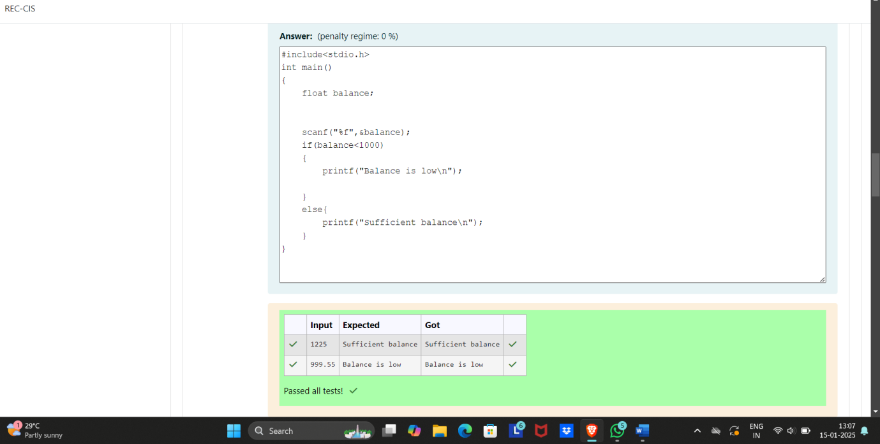

iii) Fill in the missing code in the below program to check whether the student secured first class or not.  
  
**Note-1:** Read **6** subjects marks, find total and percentage, then print the student secured first class or not.  
  
**Note-2:** If percentage is greater than or equal to **60** then print student secured first class and the percentage.

**For example:**

| **Input** | **Result** |
| --- | --- |
| 45 67 34 57 68 81 | Student did not secure a first class with 58.67% |
| 67 68 65 56 59 69 | Student secured a first class with 64.00% |

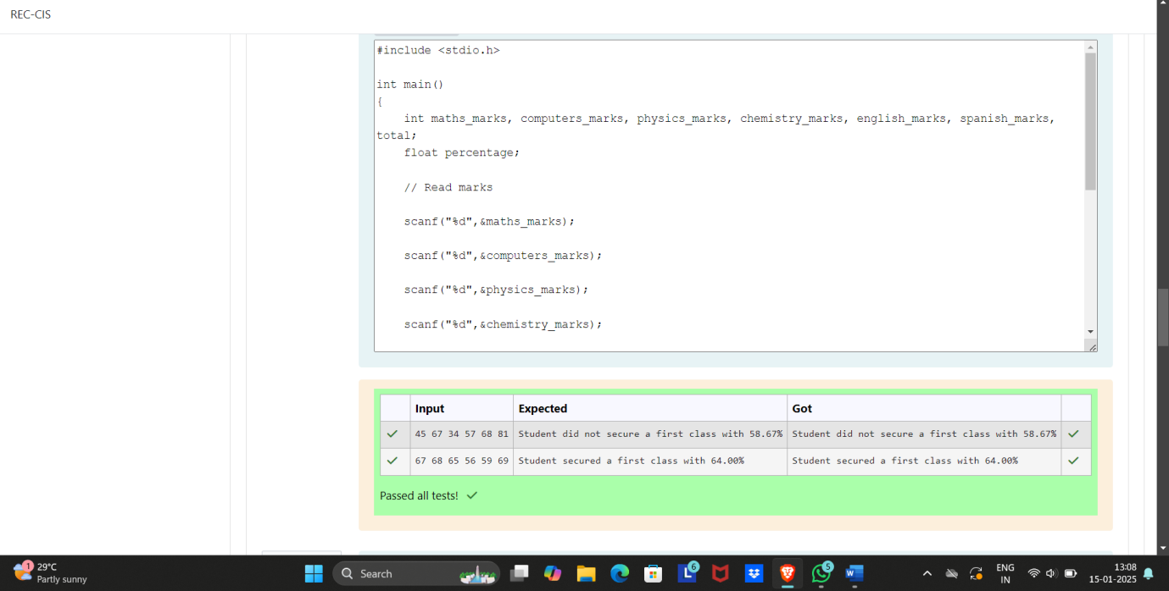

iv) Write a program which uses an if-else statement to verify and print if the given number is an odd or an even.  
  
For example, if the user gives the **input** as 10:  
10

then the program should **print** the result as:  
  
The given number 10 is an even number

If the input is given as 35, then the program should print the result as :  
The given number 35 is an odd number

**For example:**

| **Input** | **Result** |
| --- | --- |
| 35 | The given number 35 is an odd number |
| 10 | The given number 10 is an even number |
|  |  |

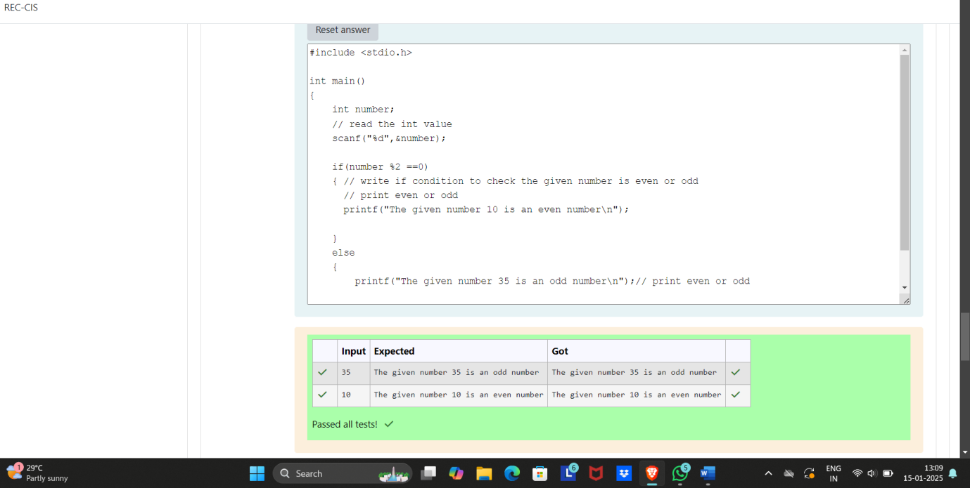

v) Write a program which uses an if-else statement to verify if the given character is an alphabet or not.  
For example, if the user gives the **input** as W:  
W

then the program should **print** the result as:  
Given character W is an alphabet

If the input us given as 7, then print the result as:  
Given character 7 is not an alphabet

[**Hint:** The ASCII values of alphabets '**A**' to '**Z**' are 65 to 90 and '**a**' to '**z**' are 97 to 122.]  
**For example:**

| **Input** | **Result** |
| --- | --- |
| W | Given character W is an alphabet |
| 7 | Given character 7 is not an alphabet |

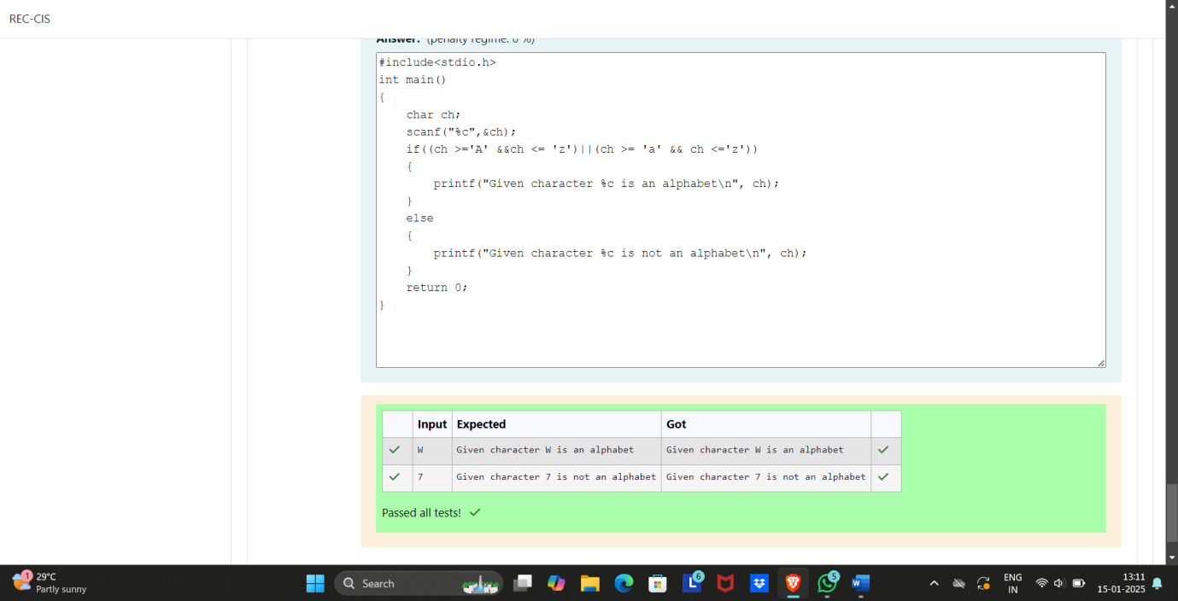

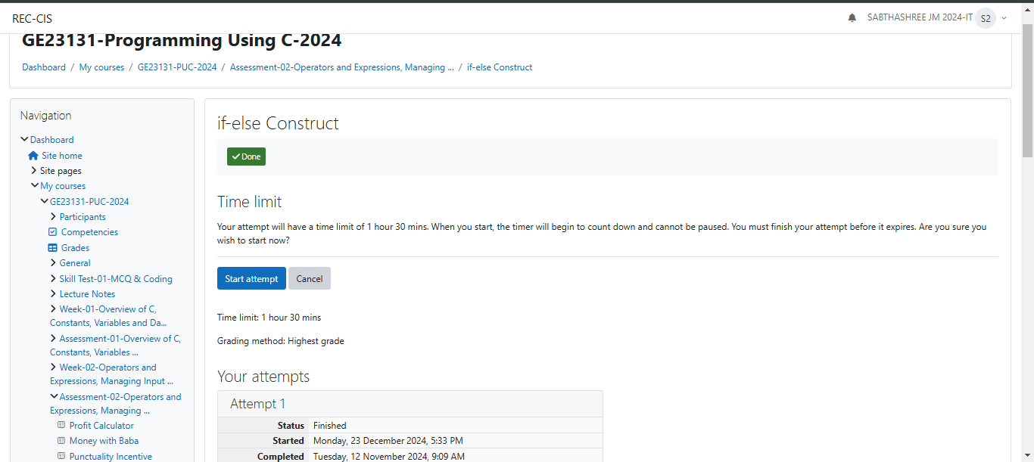

Q6) When an if-else construct appear as a statement within another if-block or a else-block, it is referred to as nesting of if-else construct.  
Below is an example of a **nested if-else** construct:

if (expression_1)   
{

if (expression_2)   
 {

if (expression_3)   
 {

statement

}   
 else   
 {

statement_2;

}

}   
 else   
 {

statement_3;

}

}

In the above syntax, the **statement_2** will be executed only when the conditions in expression_1, expression_2 and expression_3 evaluates to 1 (true).

Fill in the missing code in the below program to find the **largest** of three numbers using nested if-else.

**For example:**

| **Input** | **Result** |
| --- | --- |
| 23 56 77 | 77 is greater than 23 and 56 |

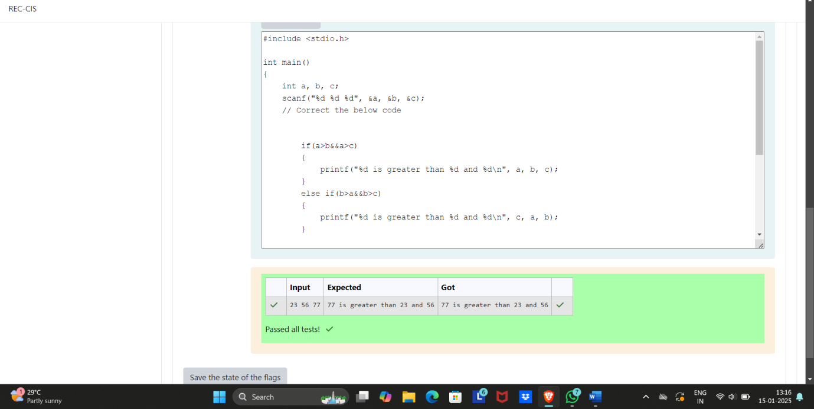

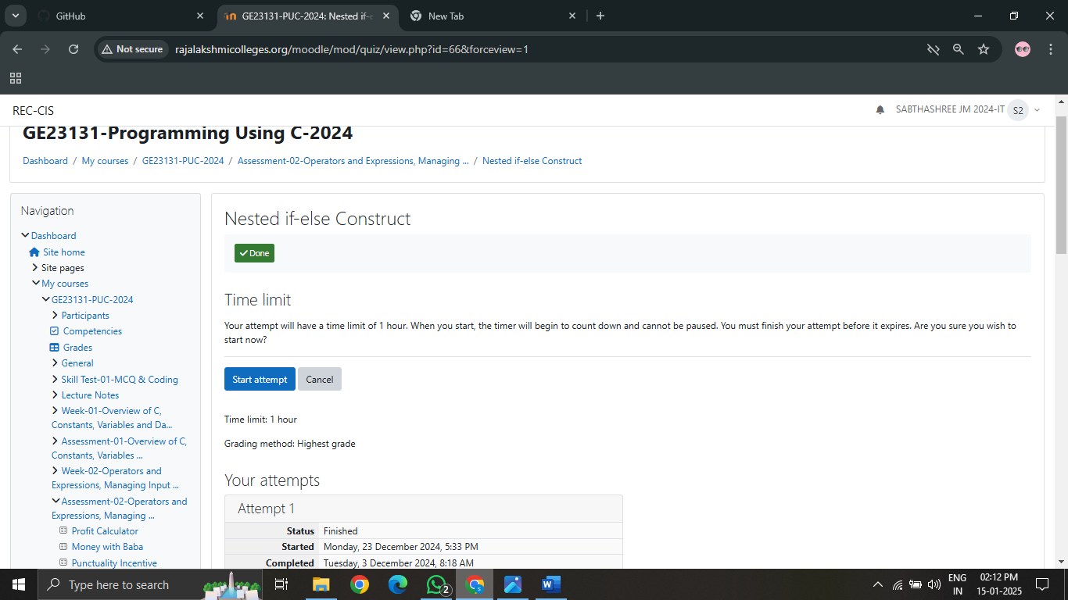

Q7i)The if-else-if construct extends the if-else construct by allowing to chain multiple if constructs as shown below:  
if (expression_1)   
{

statement_1;

}   
else if (expression_2)   
{

statement_2;

}   
else if (expression_3)   
{

statement_3;

}   
else if (expression_4)   
{

statement_4;

}   
else   
{

statement_5;

}

As shown in the above syntax, multiple if constructs can be chained to any length. The else construct which appears at the end is optional, and if it is to be included it has to be only at the end.  
  
The if-else-if construct is used whenever we have multiple mutually exclusive if conditions which work on the same input.  
  
In a if-else-if construct the conditions are evaluated from top to bottom. Whenever a condition evaluates to **true** (1), the control enters into that if-block and after that the control comes out of the complete if-else-if construct ignoring all the remaining if and else constructs that may exist below the currently satisfied if-block.  
  
For example, if the condition in the expression_2 is the first condition to evaluate to **true** after executing statement_2 the control comes out of the complete if-else-if construct.

The below program reads a character from the console and should print if the given character is an alphabet or a digit. Do not remove the existing code, add the missing lines of code which employs the if-else-if statement to produce appropriate output.

**For example:**

| **Input** | **Result** |
| --- | --- |
| A | Given character A is an alphabet |
| 8 | Given character 8 is a digit |
| % | Given character % is neither an alphabet nor a digit |

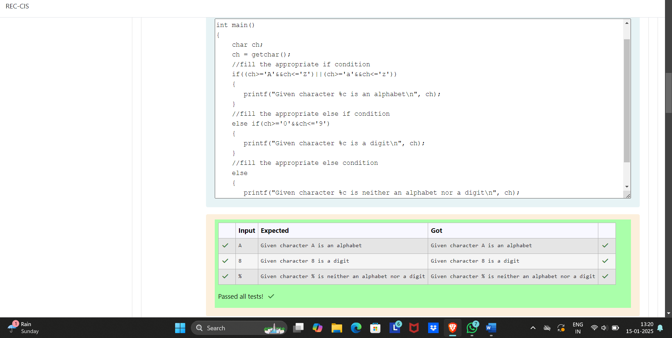

ii) The following code uses if-else statement to check whether the given integer number is a valid **leap year** or not.  
  
Use if-else statement and print "__ is a leap year":

* if a year is divisible by **4** and should not be divisible by **100**.
* If a year is divisible by **400**.

Otherwise, print "__ is not a leap year".

Fill in the missing code in the below program to check whether the given year is a **leap year** or not..

**For example:**

| **Input** | **Result** |
| --- | --- |
| 1900 | 1900 is not a leap year |

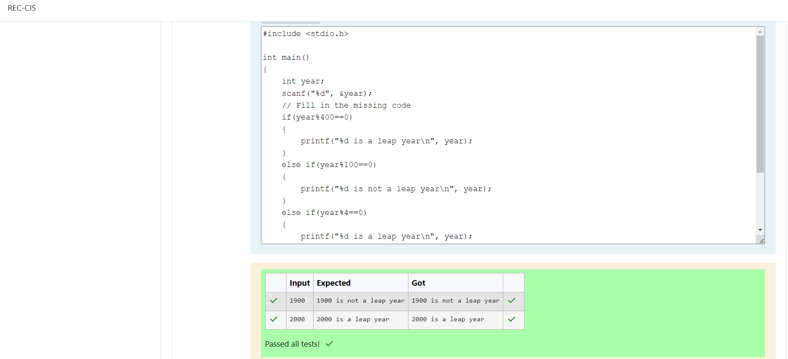

iii) Fill in the missing code in the below program to read an **integer value** for a variable age and use if-else statement to check the age and print appropriate ticket price.  
  
If **age** is lessthan or equal to **infant_age** (3 years) or greaterthan or equal to **centenarian_age** (100 years) then print **Ticket Price: 0**.  
  
Otherwise, If **age** is lessthan or equal to **child_age** (13 years) or greaterthan or equal to **senior_citizen_age** (60 years) then print **Ticket Price: 5**.  
  
Otherwise, print **Ticket Price: 10**.

**For example:**

| **Input** | **Result** |
| --- | --- |
| 34 | Ticket Price: 10 |
| 2 | Ticket Price: 0 |
| 101 | Ticket Price: 0 |
| 72 | Ticket Price: 5 |

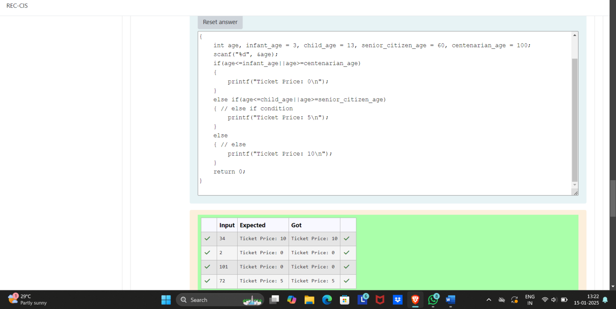

iv) See the below code which uses a if-else-if statement for calculating **AM** or **PM** for a given **hour**.  
  
In the **main()** function read an integer value between **0** and **23** for the variable hour and use if-else-if statement to display **AM** or **PM**.  
  
Fill in the if condition to check if the given hour is between **0** and **11** (both inclusive) for **AM**. Fill in the else if condition to check if the given hour is between **12** and **23** (both inclusive) for **PM**.

**For example:**

| **Input** | **Result** |
| --- | --- |
| 9 | AM |
| 22 | PM |
| 24 | Invalid Hour!! |

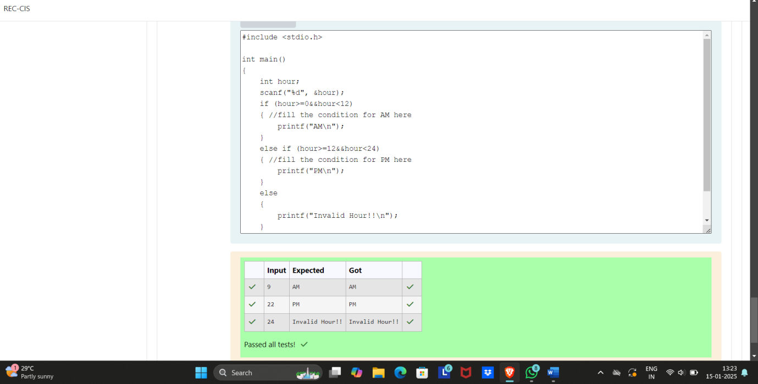

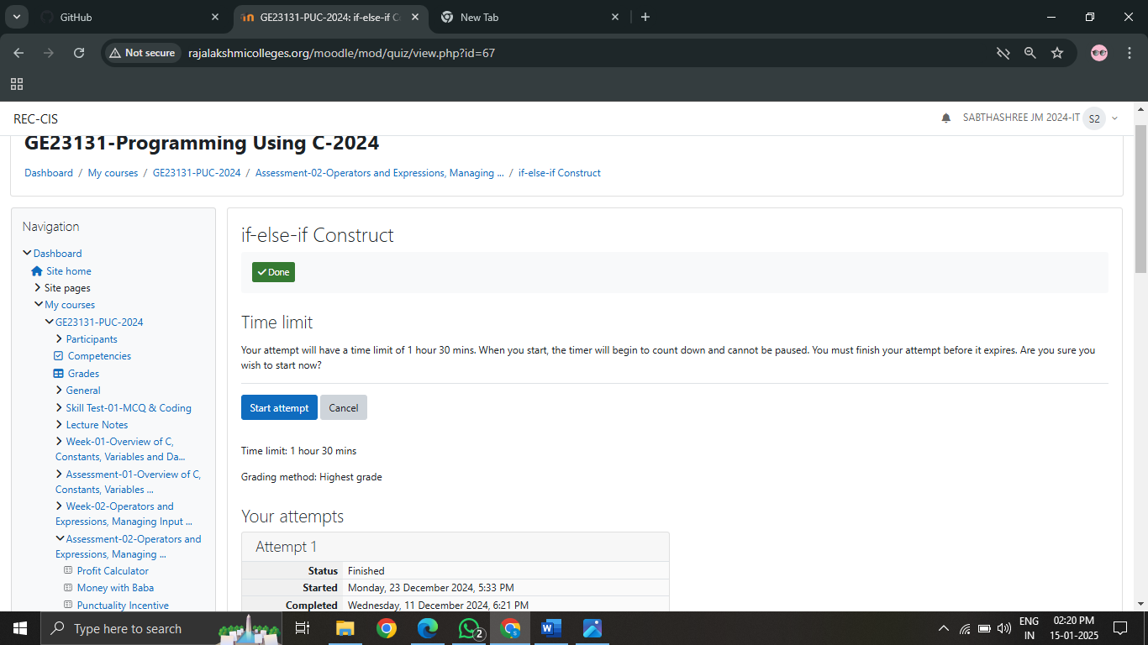

Q8i)  switch statement is used to change the control flow of a program execution through multiple paths depending on an expression's value.  
  
The below code demonstrates how to use a switch-case construct to print the corresponding English words for the digits (**1** to **9**) read from the standard input.  
  
One way is to write a long nested if-else-if for the **10** numbers or the other way is to use a switch-case statement.

See and retype the below code which demonstrates the usage of switch statement to print the English word of the given number between **1** to **9**.

#include <stdio.h>  
int main()  
{  
    int value;  
    scanf("%d", &value);  
    switch (value)  
    {  
    case 1:  
        printf("One");  
        break;  
    case 2:  
        printf("Two");  
        break;  
        case 3:  
        printf("Three");  
        break;  
        case 4:  
        printf("Four");  
            break;  
        case 5:  
        printf("Five");  
        break;  
        case 6:  
        printf("Six");  
        break;  
        case 7:  
        printf("Seven");  
            break;  
        case 8:  
        printf("Eight");  
            break;  
        case 9:  
            printf("Nine");  
            break;  
        case 10:  
            printf("Ten");  
            break;  
        default:  
            printf("Number %d is not in the range 1 to 10", value);  
    }  
    return 0;  
}

**For example:**

| **Input** | **Result** |
| --- | --- |
| 2 | Two |
| 9 | Nine |
| 15 | Number 15 is not in the range 1 to 10 |

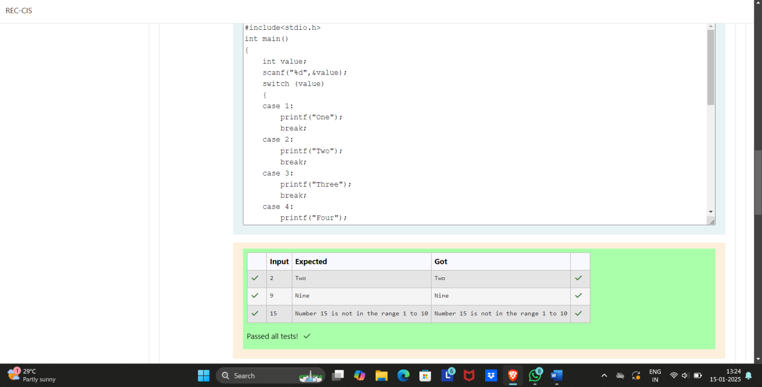

ii) Assume that the weekdays are provided with the below numbers:

Sunday ⟹ 0

Monday ⟹ 1

Tuesday ⟹ 2

Wednesday ⟹ 3

Thursday ⟹ 4

Friday ⟹ 5

Saturday ⟹ 6

Write a program to read the **weekday number** from the standard input and print the **weekday name** using switch-case.  
  
For example, if the user gives the **input** as 1:  
1

then the program should **print** the result as:  
Monday

Note: If the given input number is not in the range i.e., other than **0** to **6**, the output should be as given below:  
Invalid weekday number

**For example:**

| **Input** | **Result** |
| --- | --- |
| 6 | Saturday |
| 0 | Sunday |
| 7 | Invalid weekday number |

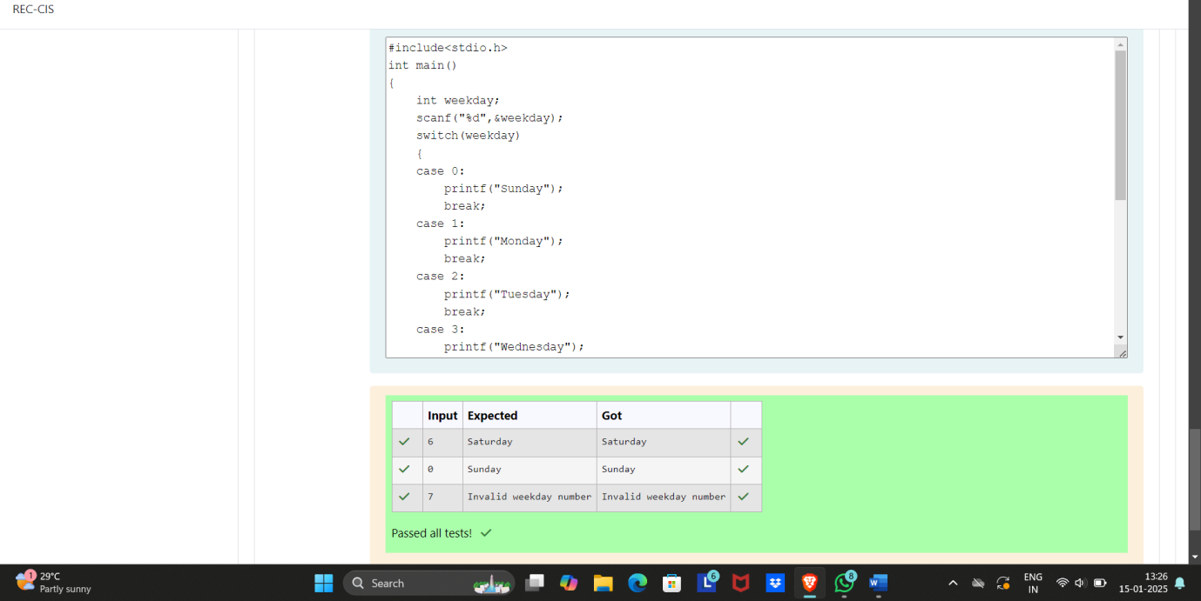

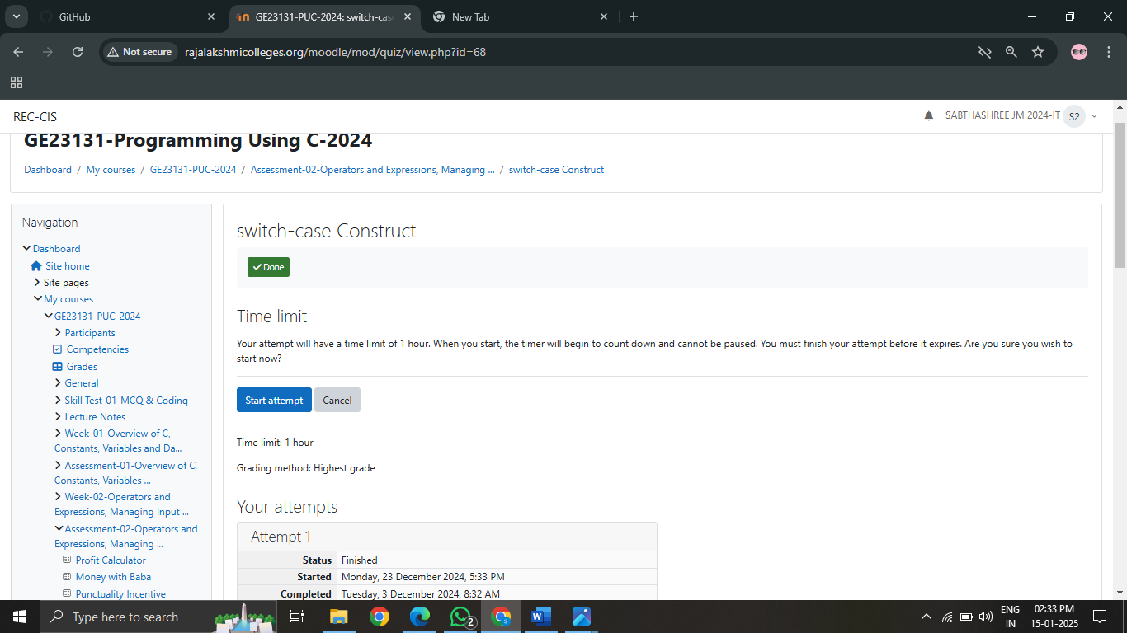

Q9i) Most of the programming languages provide a special construct/statement using which we can repeatedly execute one or more statement as long as a condition is **true**. In C, we have while, do-while and for as the three main looping constructs or statements.  
  
Below is a general syntax for using a while statement:

while (**condition**)   
{

statement_1;

statement_2;

....

}

The block of code inside the opening and closing brace which follows the while-statement is called the **while-loop**body.  
  
A while statement is used to execute some code repeatedly as long as a condition evaluates to true.  
  
The condition is an expression which should always evaluate to either true or false.

* If it evaluates to true, the body containing one or more code statements is executed.
* If the expression evaluates to false, the control skips executing the **while-loop** body.

The while-loop construct is also referred to as an entry controlled loop. Meaning, first the condition is evaluated and only if the condition evaluates to true the body of the loop is executed. After executing the body the control is automatically transferred back to the condition and the process continues until the condition evaluates to false.

See and retype the below code which uses a while-loop to read multiple numbers from standard input and prints their sum when the **sum** exceeds 100.

#include <stdio.h>  
  
int main()  
{  
    int total = 0;  
    while (total <= 100)  
    {  
    int num;  
    scanf("%d", &num);  
        total += num;  
    }  
    printf("The total of given numbers is : %d", total);  
    return 0;  
}

**For example:**

| **Input** | **Result** |
| --- | --- |
| 34  62  24 | The total of given numbers is : 120 |

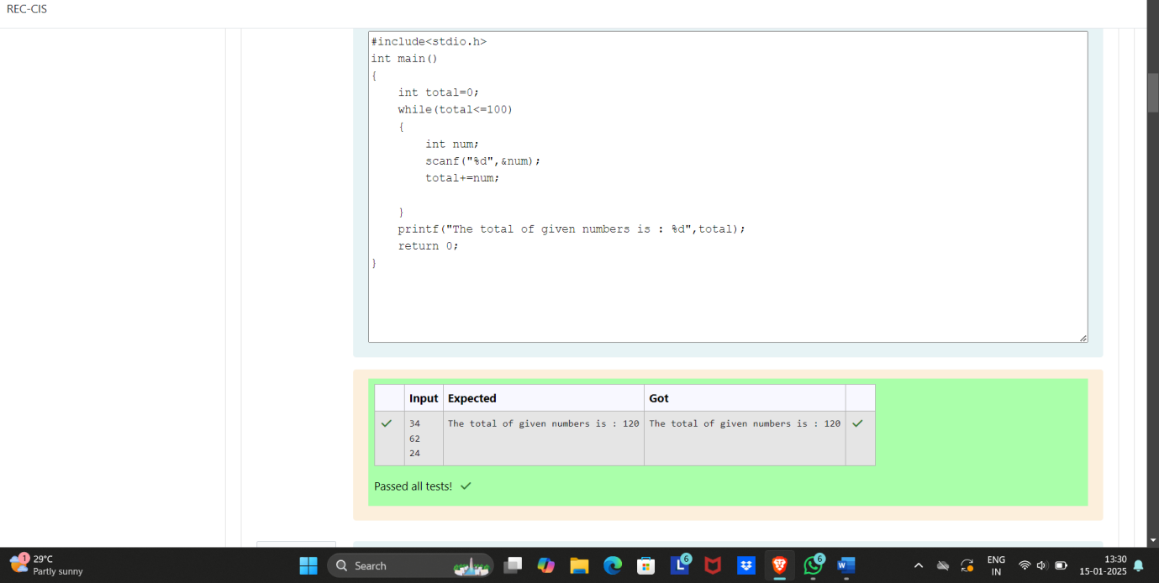

ii) The below sample code should print Ganga by number of times, where as the input is read by the programmer using **scanf()**.  
  
Fill in the missing code so that it produces the desired output.

**For example:**

| **Input** | **Result** |
| --- | --- |
| 3 | Ganga  Ganga  Ganga |

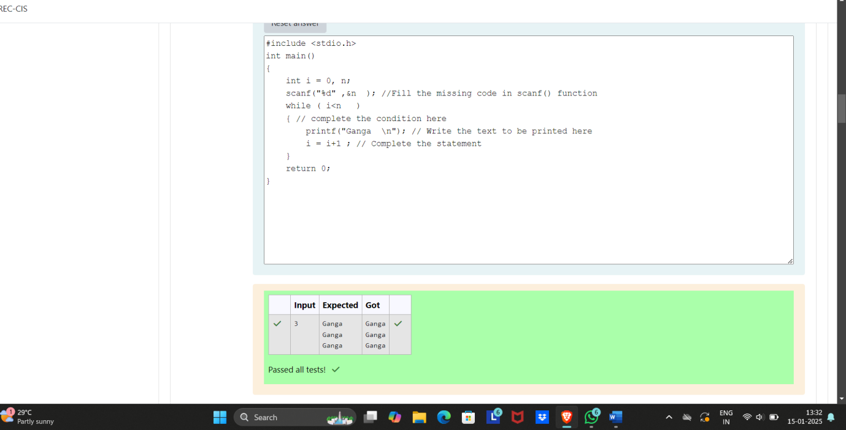

iii) Write a **C** program to print first n **natural numbers**.  
  
For example, if the user gives the **input** as :

3

then the program should **print** the result as:

The natural numbers from 1 - 3 : 1 2 3

**For example:**

| **Input** | **Result** |
| --- | --- |
| 3 | The natural numbers from 1 - 3 : 1 2 3 |
| 9 | The natural numbers from 1 - 9 : 1 2 3 4 5 6 7 8 9 |

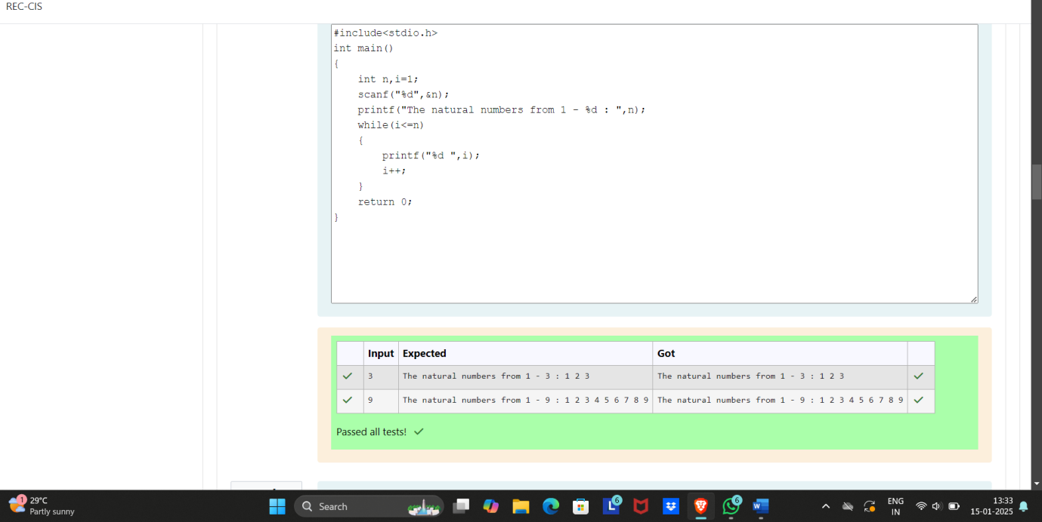

iv) The below sample code should find the sum of **even numbers** between any two numbers.  
  
[**Hint:** The numbers should be read by using scanf()].  
  
Fill in the missing code so that it produces the desired output.

**For example:**

| **Input** | **Result** |
| --- | --- |
| 3 6 | The sum of even integers between the given limits = 10 |

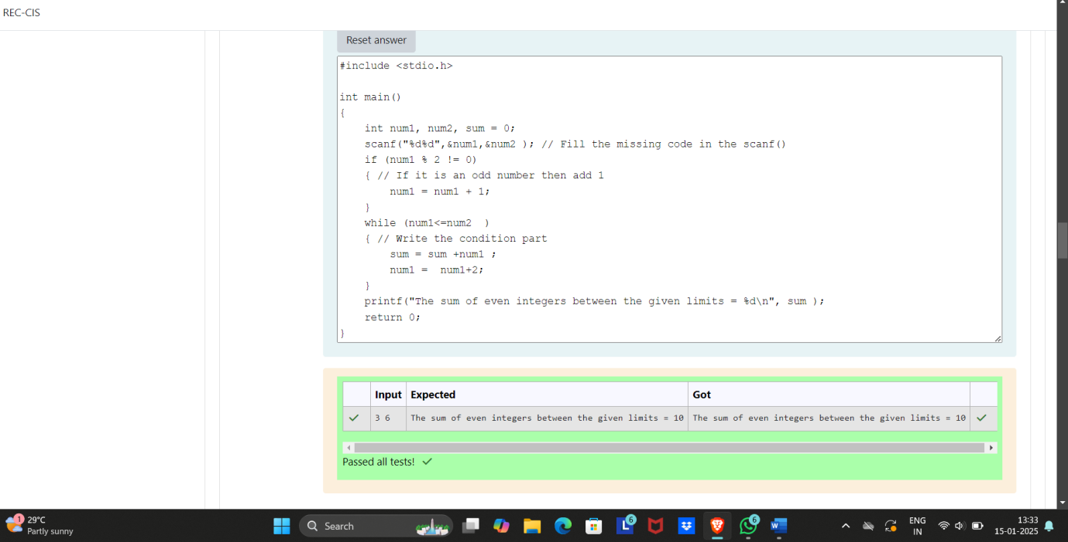

v) ill in the missing code in the below program to read an **integer number** and find the reverse of the given number.

For example if the input is 1234, then the output will be 4321.  
Hints  
The logic of reversing of any number is pretty simple if you know how to find last digit of any number. Initially the variable reverse contains zero(0), the process of reversing involves four basic steps:

* Multiply the reverse variable by 10.
* Find the last digit of the given number by applying % 10.
* Add the last digit just found to reverse.
* Divide the original number by 10 to eliminate the last digit, which is not needed anymore.

**Repeat** the above four steps till the original number becomes 0 and finally we will be left with the reversed number in reverse variable.

**For example:**

| **Input** | **Result** |
| --- | --- |
| 1234 | The reverse number of a given number = 4321 |
| 765 | The reverse number of a given number = 567 |

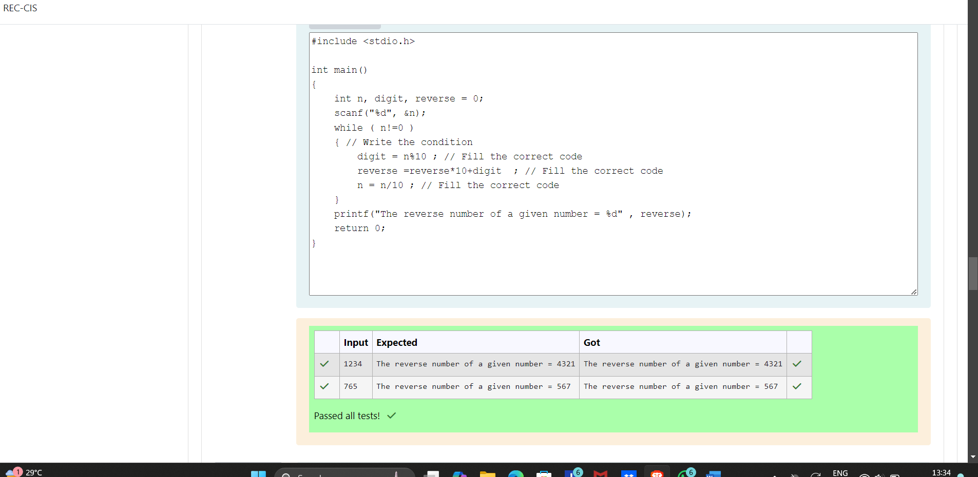

vi) ill in the missing code in the below sample program which finds the factorial of a given number.  
  
Factorial of a non-negative integer n, denoted by n!, is the product of all positive integers less than or equal to n.  
For example, 5! = 5 * 4 * 3 * 2 * 1 = 120.  
  
The below sample code computes the factorial of a given non-zero integer.  
  
The main() function declares an integer variable factorial and initializes it to 1, which it will use to store the computed factorial value.  
  
It uses a **while-loop** to iterate from 2 to n multiplying the loop counter in each iteration with the factorial and storing the product again in factorial.

**For example:**

| **Input** | **Result** |
| --- | --- |
| 2 | Factorial of given number 2 = 2 |
| 4 | Factorial of given number 4 = 24 |

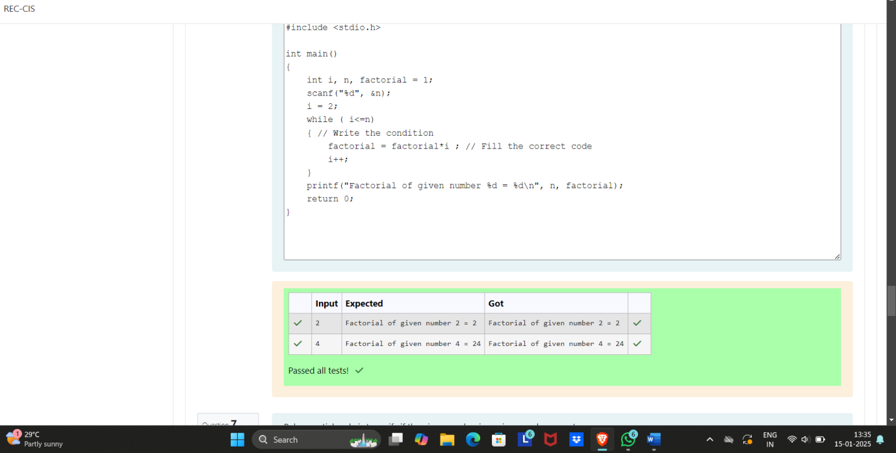

vii) Below partial code is to verify if the given number is a prime number or not.  
  
A prime number is a positive integer greater than 1, which is not divisible by any other number other than 1 and itself. Examples of a few prime numbers are 2, 3, 5, 7, 11, 13, 17, 19, etc.

Fill in the missing code so that it produces the desired output.

**For example:**

| **Input** | **Result** |
| --- | --- |
| 7 | The given number 7 is a prime number |
| 119 | The given number 119 is not a prime number |

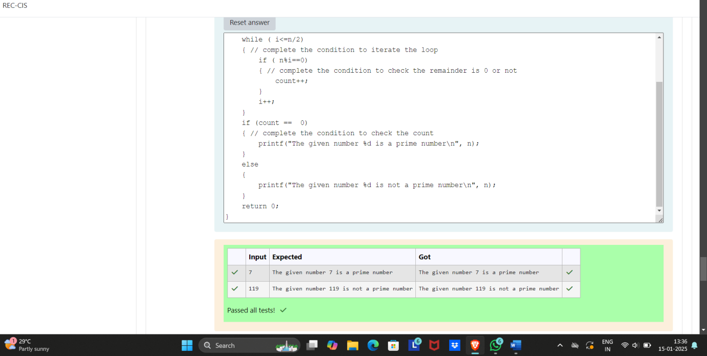

viii) Below partial code is to verify if the given number is an armstrong number or not.  
  
An armstrong number is a number that is the sum of its own digits raised to the power of number of digits that make up the original number.  
  
For example, if the given number is 153, the total number of digits are 3, and the sum of cubes of each digit (13 + 53 + 33) is equal to the same number 153. Such a number is known as an armstrong number.  
  
Let us take another example, if the given number is 9474, the total number of digits are 4, and the sum of the power of 4 of each digit (94 + 44 + 74 + 44) is equal to the same number 9474. Such a number is known as an armstrong number.  
  
Similarly,  
9 = 91 = 9  
371 = 33 + 73 + 13 = 27 + 343 +1 = 371  
3 8208 = 84 + 24+04 + 84 = 4096 + 16 + 0 + 4096 = 8208

Fill in the missing code so that it produces the desired output.

**For example:**

| **Input** | **Result** |
| --- | --- |
| 777 | The given number 777 is not an armstrong number |
| 9 | The given number 9 is an armstrong number |

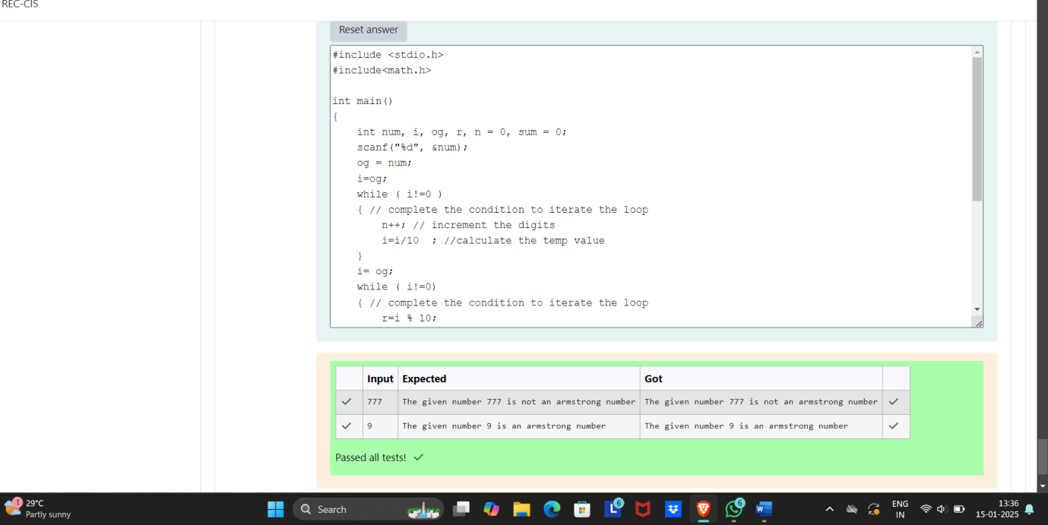

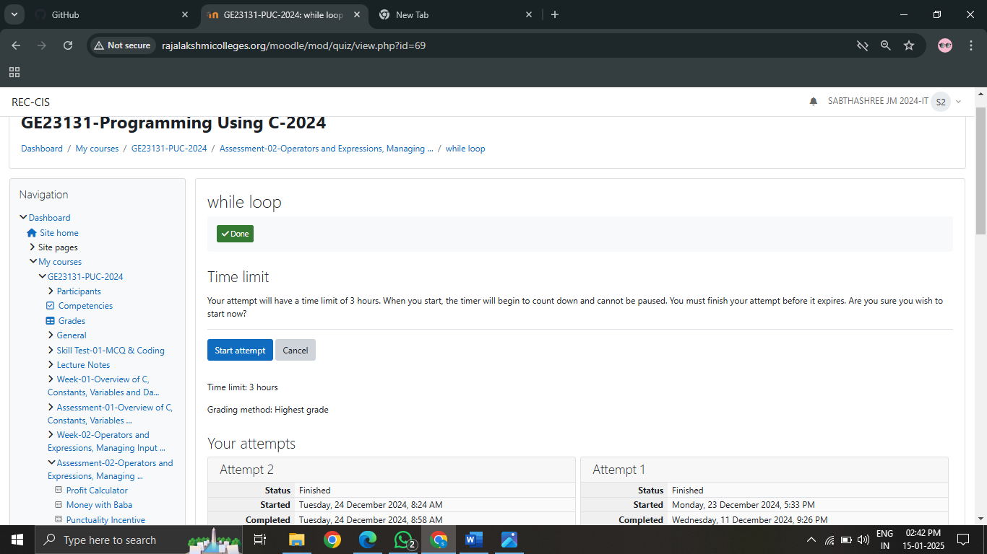

Q10i) A for-loop is used to iterate over a range of values using a loop counter, which is a variable taking a range of values in some orderly sequence (e.g., starting at 0 and ending at 10 in increments of 1).  
  
The value stored in a loop counter is changed with each iteration of the loop, providing a unique value for each individual iteration. The loop counter is used to decide when to terminate the loop.  
  
A for-loop construct can be termed as an entry controlled loop.  
Below is the syntax of a **for-loop** :

for (initialization; condition; update)   
{

statement(s);

}

1. The initialization expression initializes the loop counter; it is executed **once** at the start of the loop.
2. The loop continues to execute as long as the condition expression evaluates to true.
3. The update expression is executed after each iteration through the loop, to **increment**, **decrement** or **change** the **loop counter**.

Example with code :

**int** i;

for (i = 0; i < 10; i++)   
{

printf("%d\n",i);

}

1. Above **for-loop** statement initializes an integer variable i (which is the **loop counter**) as part of the initialization expression.
2. In the update section, it increments the variable i by **1** using the post-increment expression i++.
3. The expression in condition is i < 10. The for-loop keeps on executing the code inside the loop body as long as this condition evaluates to true. And the loop terminates when the condition evaluates to false.
4. It is a good practice to always keep the loop body (which contains the code to be executed) within an opening-brace { and a closing-brace }.

**Note :** No ; at the end of the for statement.

Complete the below code to check your understanding of the for-loop syntax. The completed code should print numbers from 10 to 20, one per line.

**For example:**

| **Result** |
| --- |
| 10  11  12  13  14  15  16  17  18  19  20 |

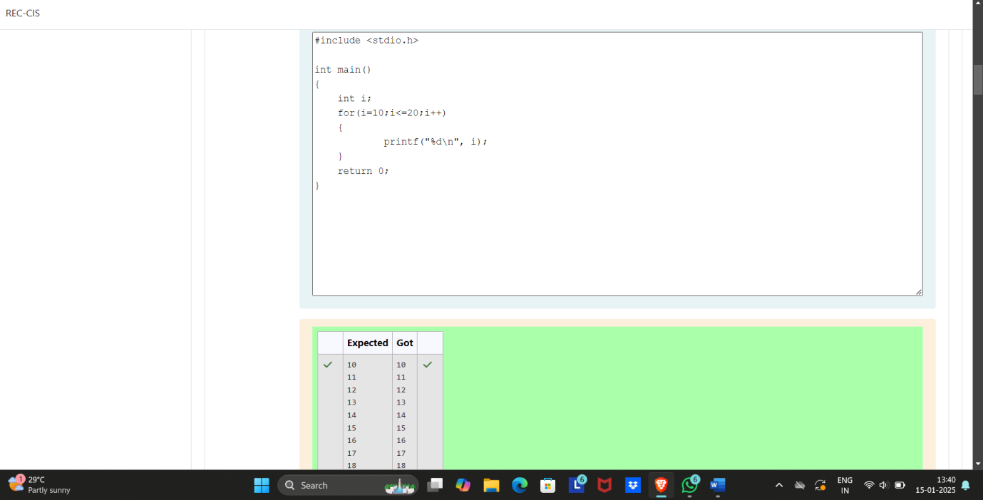

ii) Fill in the missing code in the below program to calculate the value of an, given two positive non-zero integers a and n.  
  
The code in the main() function reads two integers from standard input and stores them in the variables a and n.  
  
It uses a for-loop to multiply a with itself n number of times.  
  
Variable a_power_n is used to store the computed value of an.  
  
After the execution of for-loop is completed, the final value of a_power_n is printed to the standard output.

**For example:**

| **Input** | **Result** |
| --- | --- |
| 2 3 | 8 |

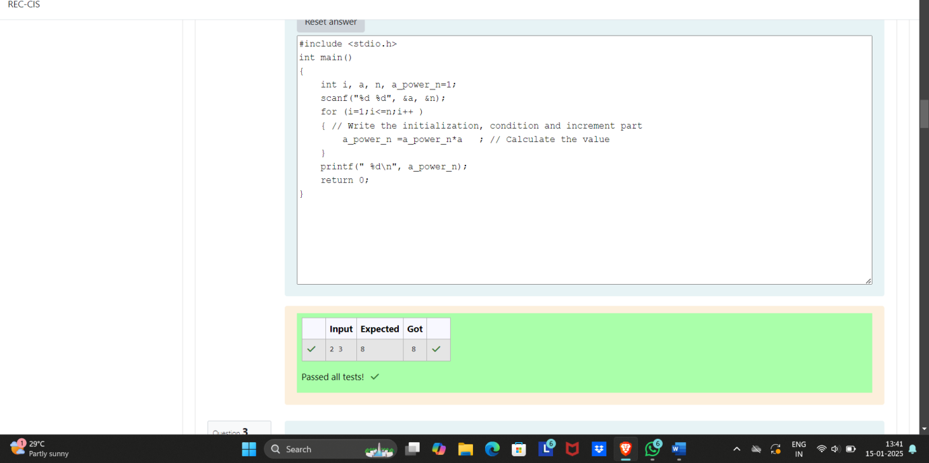

iii) Write a program to find **sum** and **mean** of **n** numbers.

**Constraints:**

* 1 <= n <= 106
* 10-3<= elements <= 103
* Result of mean should print upto**2 decimal places**.

**Sample test case**:

4------------------------> First line of input is the value on n.

3 5 7 8-----------------> Second line of input is n space separated integer values.

Sum: 23--------------->Third line prints the Sum as required.

Mean: 5.75------------>Fourth line prints the Mean as required.

**Instruction:** To run your custom test cases strictly map your input and output layout with the visible test cases.

**For example:**

| **Input** | **Result** |
| --- | --- |
| 4  3 5 7 8 | Sum: 23  Mean: 5.75 |

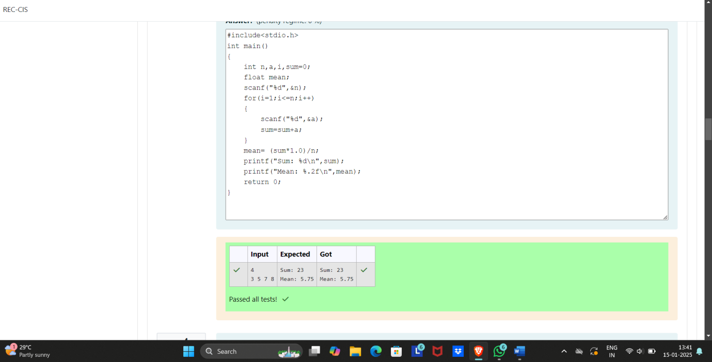

iv) ill in the missing code in the below program to print the Fibonacci series i.e., 0 1 1 2 3 5 8 13 21....., up to the limit.  
  
The code in the main() function reads one integer variable n. It uses a for loop to iterate from 0 to n and print the series.  
  
By definition, the first two numbers in the Fibonacci sequence are 0 and 1, and each subsequent number is the sum of the previous two.

**For example:**

| **Input** | **Result** |
| --- | --- |
| 25 | The Fibonacci series is : 0 1 1 2 3 5 8 13 21 |

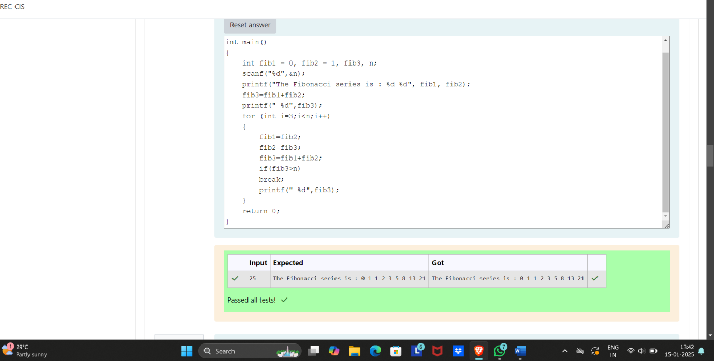

v) Write a program that will print all the **English alphabets** from A to Z, each in a new line.

Hints

1. The code in the main() function can use a for loop to iterate over the characters 'A' to 'Z'.
2. Note that char data type is a numeric type and can be used in a for loop as a loop counter.
3. You can declare and initialize a loop counter char i and initialize it to 'A' (eg: char i = 'A';). The condition can similarly be i <= 'Z'; and the update statement can be i++.
4. You can then print i directly which is of type char, using the **printf()** function with a newline character (\n).

**For example:**

| **Result** |
| --- |
| A  B  C  D  E  F  G  H  I  J  K  L  M  N  O  P  Q  R  S  T  U  V  W  X  Y  Z |

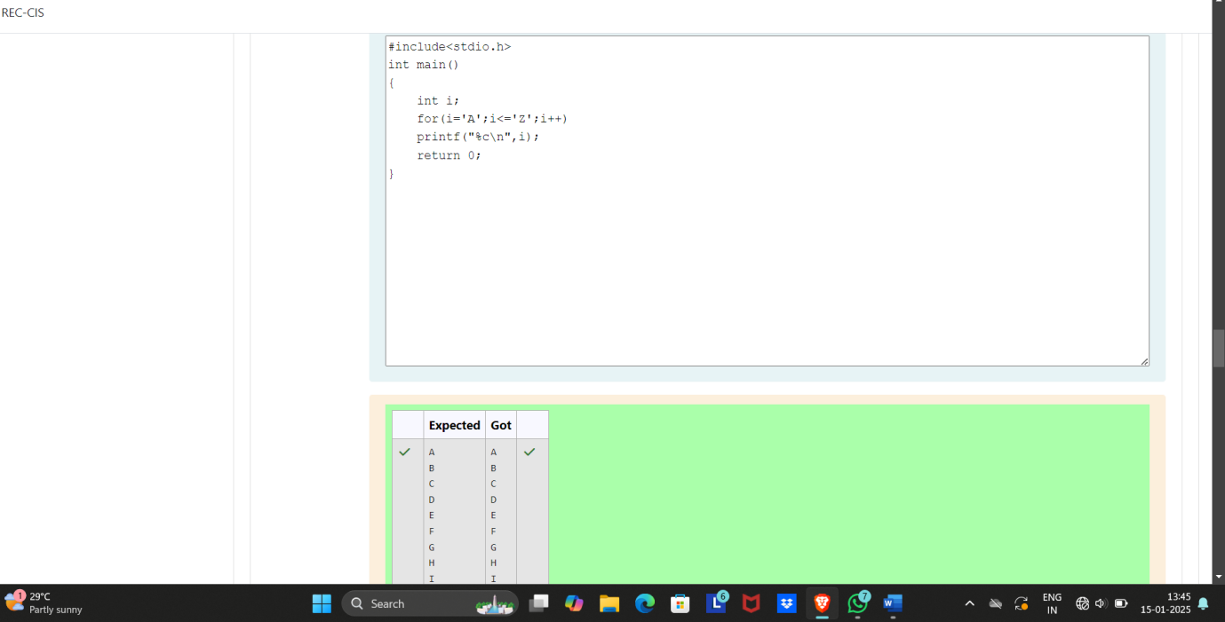

vi) Write a program to read **n** numbers from the user and then count number of "**Odd"** and "**Even"** numbers.

**Constraints:**

* 1 <= n <= 106
* 10-3<= elements <= 103

**Sample test case**:

3----------> First line of input is n i.e. 3.

5 6 7-------> Second line of input is n space separated integer values/elements.

Even: 1-----> Third line prints the output (the count of even elements).

Odd: 2------->Fourth line prints the output (the count of odd elements).

**Note:** Do use the **printf()** function with a **newline** character (**\n**) to print your results on newline.

**Instruction:** To run your custom test cases strictly map your input and output layout with the visible test cases.

**For example:**

| **Input** | **Result** |
| --- | --- |
| 3  5 6 7 | Even: 1  Odd: 2 |

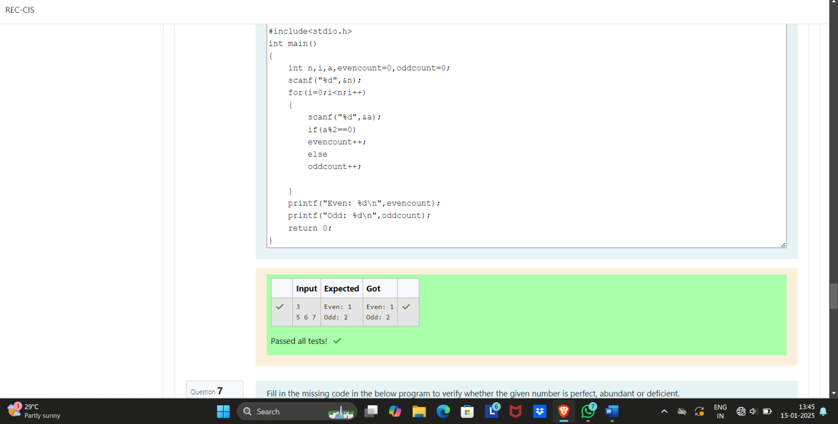

vii) ill in the missing code in the below program to verify whether the given number is perfect, abundant or deficient.  
  
A number is said to be perfect if it equals the sum of its proper divisors. For example, **6** and **28** can be called **perfect numbers** as : **6 = 1 + 2 + 3** and **28 = 1 + 2 + 4 + 7 + 14**.  
  
Alternatively, if the sum of a number's proper divisors **exceeds** the number itself, it is said to be abundant, while if the sum of a number's proper divisors is **less-than** the number itself, it is said to be deficient.

**For example:**

| **Input** | **Result** |
| --- | --- |
| 6 | The given number 6 is a perfect number |
| 10 | The given number 10 is a deficient number |
| 12 | The given number 12 is an abundant number |

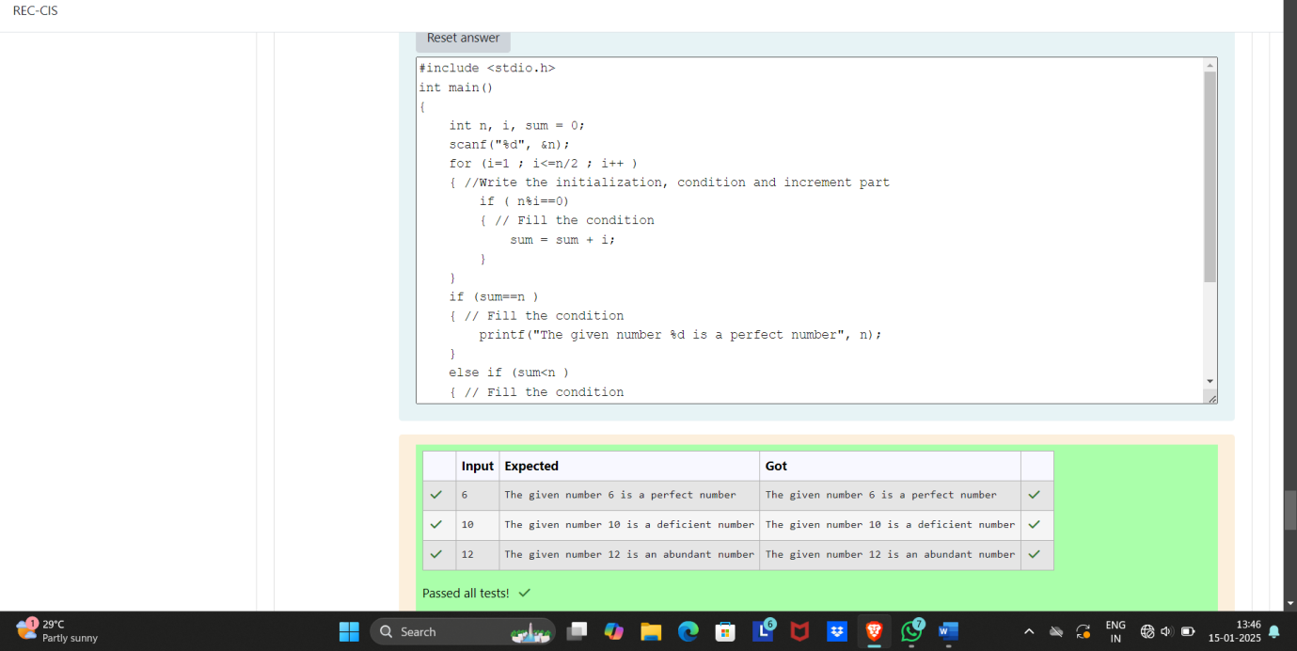

viii) Fill in the missing code in the below program to check whether the given number is a strong number or not.  
  
A number is called strong number if sum of the **factorials** of its digit is equal to number itself. For example: **145** is considered a strong number since **1! + 4! + 5! = 1 + 24 + 120 = 145**.  
  
The code in the below main() function reads a number from standard input and performs the verification for a strong number by extracting the individual digits and calculating their factorials.

**For example:**

| **Input** | **Result** |
| --- | --- |
| 145 | The given number 145 is a strong number |
| 123 | The given number 123 is not a strong number |

